Tour Hunting Website
Software Requirements Specification

Version 1.0.0



Supervisor Name: Ehsan ul Haq

Revision History
Date (dd/mm/yyyy) | Version | Description | Author
21/06/2023 | 1.0.0 | - Scope  - Function and Non-Functional Requirements  - Use-Case Diagram  - Usage Scenarios  - Adopted Methodology  - Work Plan

Table of Contents

- Scope (of the project)
- Functional Requirements Non Functional requirements
- Use Case Diagram
- Usage Scenarios
- Adopted Methodology
- Work Plan (Use MS Project to create Schedule/Work Plan)

SRS Document

Scope of Project:

Scope of Tour Hunting Website is very considerable because it can provide the facility to companies to find the more customers who want to go on a tour and also provide the facilities to the user who want to go to tour. By using our application finding the best tour plan will become too much easy.

This feature will makes it very useful in Business field. As someone can quickly find or use filters such as destination, activity, duration and price range etc. Our application will provide the facility to users and companies to get register themselves at any time 24/7 at any time and at anyplace to become the part of our tour hunting website and its registration request will approve by an Admin It will be easily accessible to everyone.

Our application will not sacrifice the security of its users. Our application also provides customer support through various channels such as phone, email and suggestion box. In our application only admin have full rights to manage or to modify user’s information.

Our application will provide stability, high performance, cost-effectiveness and great user-friendly interface. It will be smart enough to work and too compatible regardless of a device. Our application can browse on any search engine.

Functional & Non-Functional Requirements:

Functional Requirements:

Admin:

- Admin will be able to login into the application.
- Admin can search/view/add/update/delete any information.
- Admin can approve/reject registration requests.
- Admin can reply to customers questions.

User:

- User will be able to register into the application.
- User can login after Admin approves his/her registration request.
- User will be able to search tours using search engine.
- User will be able to compare multiple tours to find the best tour.
- User will be able to book the tours using application.
- User will be able to add reviews and ratings after the tour for the other users.
- User will be able to send messages through customer support to the admin in case of any issues they may have.

Tour Provider Company:

- Company will be able to register into the application.
- Company will be able to login into the application.
- Company will be able to post the tour details such as price, number of tourists and locations etc.
- Company will be able to view their booking history and revenue they made.

NON-Functional Requirements:

Reliability:
The ability of our system to behave consistently in a user-acceptable manner when operating within the environment for which the system was intended. For example our system will be able to update process must roll back all related updates in database when any update fails.

Usability:
Usability defines how difficult it will be for a user to learn and operate the system. In our system all users will be satisfied with the usability of the system.

Security:
In our application proper login system will be create because we‘ll secure to our application from hacking and unauthorized persons.

Maintainability:

Maintainability measures the ease and speed with which a system can be restored to operational status after a failure occurs.

Recoverability:
Our system will be able to make a recovery from a crash. Our system has the inbuilt ability to recover them.

Integrity:
In our application maintained accurate and authentic data.

Use Case Diagrams:

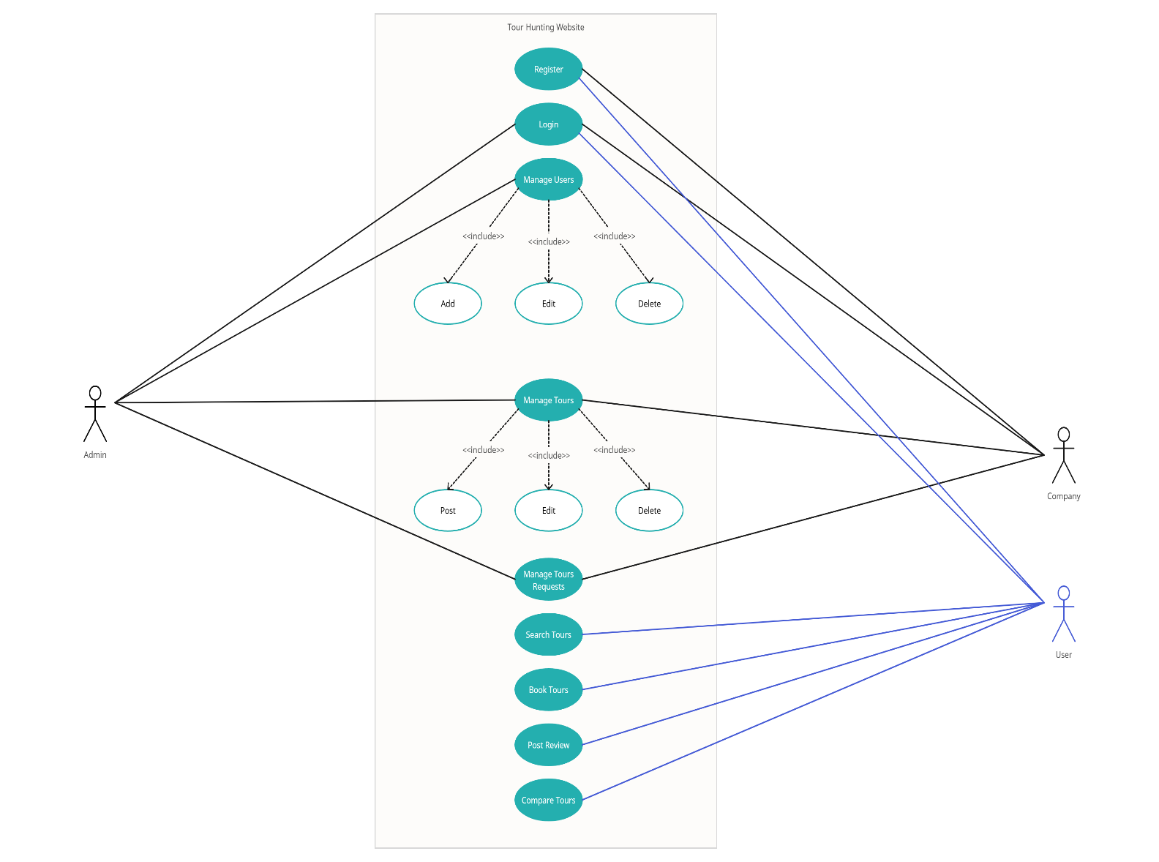

Usage Scenarios:

Use Case Title | Register
Use Case Id | 1
Actors | User, Company
Description | Members can create his/her account through registration interface.
Pre-condition | Members have to fill the registration form and submit.
Sequence Of Actions | - Fill the registration Form.  - Submit the registration form.
Post-condition | Registration info will be saved into the database and members will wait for registration request approval.
Exceptions | System shows decent warning, on duplication of registration info.

Use Case Title | Login
Use Case Id | 2
Actors | Admin, Registered-User, Registered Company
Description | Application will provide the decent login interface where members can provide their valid email and password for login into their account.
Pre-condition | Admin, Company and registered user must have valid email and password for login.
Sequence Of Actions | - Fill the login form with valid email and password.  - Submit.
Post-condition | If email and password is correct then admin, company and user will be redirected to their accounts and can easily manage their accounts.
Exceptions | Exception occur if, email or password is not correct.

Use Case Title | Manage Users
Use Case Id | 3
Actors | Admin
Description | Admin will be able to manage all the details of the users and companies.
Pre-condition | Login into the application. Go to manage users’ section and apply desired CRUD operations there
Sequence Of Actions | - Admin must be login.  - Go to manage user’s section.  - Apply crud operations there.
Post-condition | Request status will updated on database, if it’s approved then user of the application will able to login into their account.
Exceptions | -

Use Case Title | Manage Tours
Use Case Id | 4
Actor | Admin, Company
Description | Admin has full-fledged rights on the application, he/she will be able to manage all information in the application. He/she will be able to manage any specific Tour info as well. Tour Provider Company will be able to manage his/her own posted tours using this application.
Pre-condition | Admin and company must be logged-in before managing tour details.
Sequence Of Actions | - Login.  - Go to manage tours section.  - Perform any CRUD operation on tour.
Post-condition | Information will be updated in database according to CRUD operation and application shows alert related to performed operation on tour info.
Exceptions | Exception occurs on any duplications of tour info or on try to apply operation on invalid tour id etc.

Use Case Title | Manage Tour Requests
Use Case Id | 5
Actor | Company
Description | Tour provider company will be able to view, approve and reject any tour requests from the customer.
Pre-condition | Company must be logged-in before managing tour request details.
Sequence Of Actions | - Login.  - Go to manage tours requests section.  - View, approve or reject requests there.
Post-condition | Information will be updated in database according to operation and application shows alert related to performed operation on requests.
Exceptions | None.

Use Case Title | Search Tours
Use Case Id | 6
Actor | Users
Description | All the users will be able to search any tour by entering the keywords or using the different filters such as location, price ranges, durations and activity etc.
Pre-condition | Application must be in running-state.
Sequence Of Actions | - Run the application.  - Search using search bar.
Post-condition | All the tours related to searched keyword or selected filters will appear there.
Exceptions | Exception will occur if there is no record found related to search or filters.

Use Case Title | Book Tours
Use Case Id | 7
Actor | Users
Description | User of the application will be able to boot the tour by clicking on apply for this tour button.
Pre-condition | Application must be in running-state and user must be logged-in.
Sequence Of Actions | - Login into the application.  - Go to book tour page.  - Click book tour button.
Post-condition | A booking tour request will be sent to the owner of this tour.
Exceptions | Exception will occur if user already sent the booking request.

Use Case Title | Post Review
Use Case Id | 8
Actor | Users
Description | User will be able to post review and ratting after the tour for other users.
Pre-condition | User must be logged-in. After that go to the post review or ratting page, post review/ratting there.
Sequence Of Actions | - Login into the application.  - Go to review/ratting page.  - Add review/ratting there.
Post-condition | According to this action a new review/ratting will be added into the database.
Exceptions | Exception will occur if user give the same review/ratting on same tour.

Use Case Title | Compare Tours
Use Case Id | 9
Actor | Users
Description | Users will be able to compare the tour packages in order to find the most suitable tour according to their budget.
Pre-condition | Application must be in running-state.
Sequence Of Actions | - Run the application.  - Open compare packages section.  - Add tour packages to compare.
Post-condition | According to this action the result using filters on the compare page will appear there.
Exceptions | None.

Adopted Methodology:-

VU Process Model is the best adopted methodology for this application due to hybrid approach of this model, which makes this model great, easy to follow and effective at the same time, because vu process model is the combination of the waterfall model and spiral model. There are many reasons for choosing this model such as it is very simple and we get benefits from both methodologies (waterfall and spiral model). Vu Process model effectively help us in planning, requirements gathering, risk analysis, development and client satisfaction etc. This methodology is easy to follow as compare to any other non-hybrid methodology, by using this methodology we can track our project progress at any time, this methodology is provide very clean approach for bug finder and removal because due to its nature when we pass requirements to this methodology’s life cycle, these requirements have to pass through each stage, if requirement is not cleared any stage, then these requirements will not be able to become the part of the project. So Vu Process Model is very secure in nature and best approach for project development.
Diagram of VU Process Model:

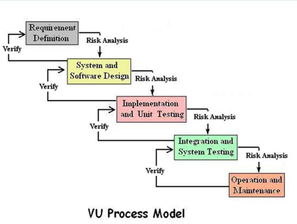

Work Plan:

